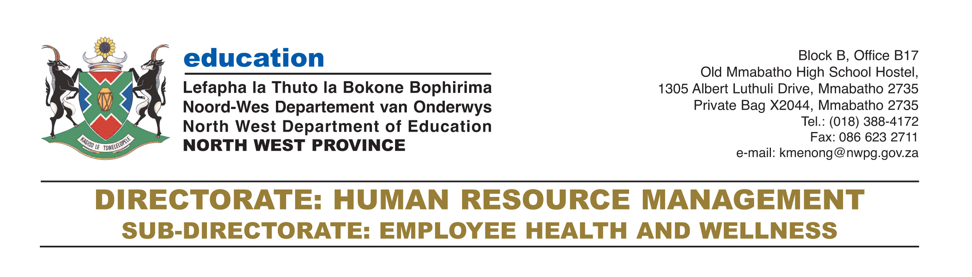

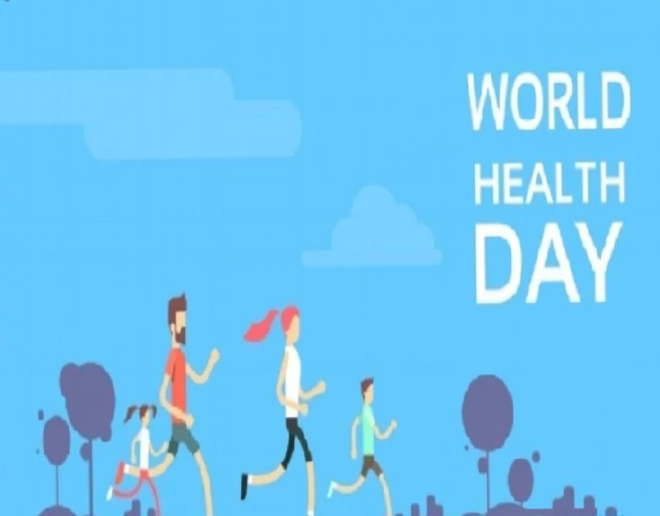

7th April, WORLD HEALTH DAY.

As we continue to reflect on COVID-19, let us also take into cognisance other health aspects of our lives. Le us continue to maintain balance!

“Employee Wellness, Our No1 Priority” 0828002175 /0829525998/0826465966

