

NATIONAL
SENIOR CERTIFICATE

GRADE 10

PHYSICAL SCIENCES/FISIESE WETENSKAPPE

JUNE/JUNIE 2017
MEMORANDUM

TIME/TYD : 2 HOURS/URE

MARKS/PUNTE: 150

This memorandum consists of 8 pages.
Hierdie memorandum bestaan uit 8 baldsye

QUESTION/VRAAG 1

1.1 C ✓✓ (2)

1.2 D ✓✓ (2)

1.3 B ✓✓ (2)

1.4 D ✓✓ (2)

1.5 B ✓✓ (2)

1.6 C ✓✓ (2)

1.7 C ✓✓ (2)

1.8 D ✓✓ (2)

1.9 C ✓✓ (2)

1.10 B ✓✓ (2)
[20]

QUESTION /VRAAG 2

2.1 Pure substance: A substance that cannot be separated into simpler
components by physical methods. ✓ ✓
Suiwer stof. ‘n Stof wat nie in kleiner komponente d.m.v. fisiese metodes verdeel kan word nie✓✓ (2)

2.2.1 Homogeneous✓ : Composition is uniform and all components a in
the same phase. ✓
Homogeen: ✓ Die komposisie is uniform en alle komponente is in
dieselfde fase ✓ (2)
2.2.2 Heterogeneous✓: Composition is non-uniform and components are easily
identified. ✓
Heterogeen. ✓Die komposisie is nie uniform nie en kan maklik idetifiseer word✓ (2)

2.3.1 Chlorine ✓Chloor (1)
2.3.2 17 ✓ (1)
2.3.3 19✓ (1)
2.3.4 17✓ (1)
2.3.5 K✓ (1)
2.3.6 19✓ (1)
2.3.7 20✓ (1)
2.3.8 19✓ (1)
2.4.1 Thermal Conductors: Material that allows heat to pass through easily. ✓✓
Termiese geleiers: Materiaal wat hitte maklik deurlaat ✓✓ (2)
Insulators: Material that does not allow heat to pass through. ✓✓
Isoleerders: Materiaal wat nie hitte deurlaat nie. ✓✓ (2)
2.4.2 The base/bottom of the pot✓Die bodem van die pot ✓ (1)
2.4.3 The handle of the pot✓Die handvatsel van die pot ✓ (1)
[20]

QUESTION 3 / VRAAG 3

3.1.1 Amonia✓Amoniak✓ (1)

3.1.2 NH₃ ✓✓ (2)

3.2 Ionic Bonding: The transfer on electrons to form cations and anions that
attract each other to form a formula unit. ✓✓
Ioniese Binding: Die oordrag van elektrone om katione en anione te vorm
wat mekaar aantrek om ‘n formule eenheid te vorm✓ ✓ (2)
3.3.1 Ionic bond ✓✓Ioniese bindng ✓✓ (2)

3.3.2
1s
2s
2p_{y}
2p_{z}
2p_{x}
n = 1
n = 2
3s
3p_{y}
3p_{z}
3p_{x}
n = 3
Criteria for Aufbau diagram: | Mark
1s with 2 e⁻ with opposite spins  1s met 2 e wat teenoorgesteld spin | ✓
2s with 2 e⁻ with opposite spins  2s met 2 d wat teenoorgesteld spin | ✓
2p_{x},2p_{y} and 2p_{z} each with 2 e⁻ with opposite spins  2p_{x},2p_{y} en 2p_{z} elk met 2 e wat teenoorgesteld spin | ✓
3s with 2 e⁻ with opposite spins  3s met 2 e wat teenoorgesteld spin | ✓
3p_{x},3p_{y} and 3p_{z} each with 2 e⁻ with opposite spins  3p_{x},3p_{y} en 3p_{z} elk met 2 e wat teenoorgesteld spin | ✓

(5)

3.3.3 Hund’s Rule✓: No pairing of electron in P orbital until each orbital has at
least one electron. ✓✓
Hund se wet: ✓ Geen paring van die elktrone in die P orbitale todat elke orbital
ten minste een elkektron bevat✓ ✓ (3)
Pauli’s Exclusion Principle✓: An orbital can accommodate a maximum
of two electrons with opposite spins. ✓✓
Pauli se uitsluitings beginsel. ✓ Elke orbital kan n maksimum van 2 elektrone
bevat wat teenoorgesteld spin✓✓ (3)

[18]

QUESTION 4 / VRAAG 4

4.1 Transverse Pulse: A pulse in which the particles of the medium moves at
right angles to the direction of motion of the pulse. ✓✓
Tranversale puls: ‘n Pulse waar die deeltjies van die medium loodreg tot die rigting van beweging voortbeweeg✓ (2)

4.2 T (1 wave) = 2s
T (8 waves) = 8 × 2s ✓
T (8 waves) =16 s ✓ (2)

4.3 T = 2 s✓ (1)

4.4 $λ$= $\frac{4}{2}$ ✓ = 2m ✓ (2)

4.5 f =$\frac{1}{T}$✓
f = $\frac{1}{2}$✓
f = 0,5sec ✓ (3)

4.6 v = f $λ$ ✓
v = 0,5Hz×2m ✓
v = 1 m.s⁻¹ ✓ (3)

[13]

QUESTION/VRAAG 5

5.1 Principle of the superposition of waves: The algebraic sum of the
amplitudes of two pulses that occupy the same space at the same time
OR The addition of the disturbances of the two pulses that occupy the
same space at the same time. ✓✓

Beginself van die superposisie van golwe: Die algebriese som van die amplitudes van twee pulse wat dieselfde ruimte gedurende dieslefde tyd bevat. ✓✓
OF Die som van die versteuring van twee pulse wat dieselfde ruimte in dieslfde tyd bevat. (2)
5.2.1 Constructive interference ✓ Konstruktiewe interferensie (1)
5.2.2 Destructive interference ✓ Destruktiewe interferensie (1)

5.3.1

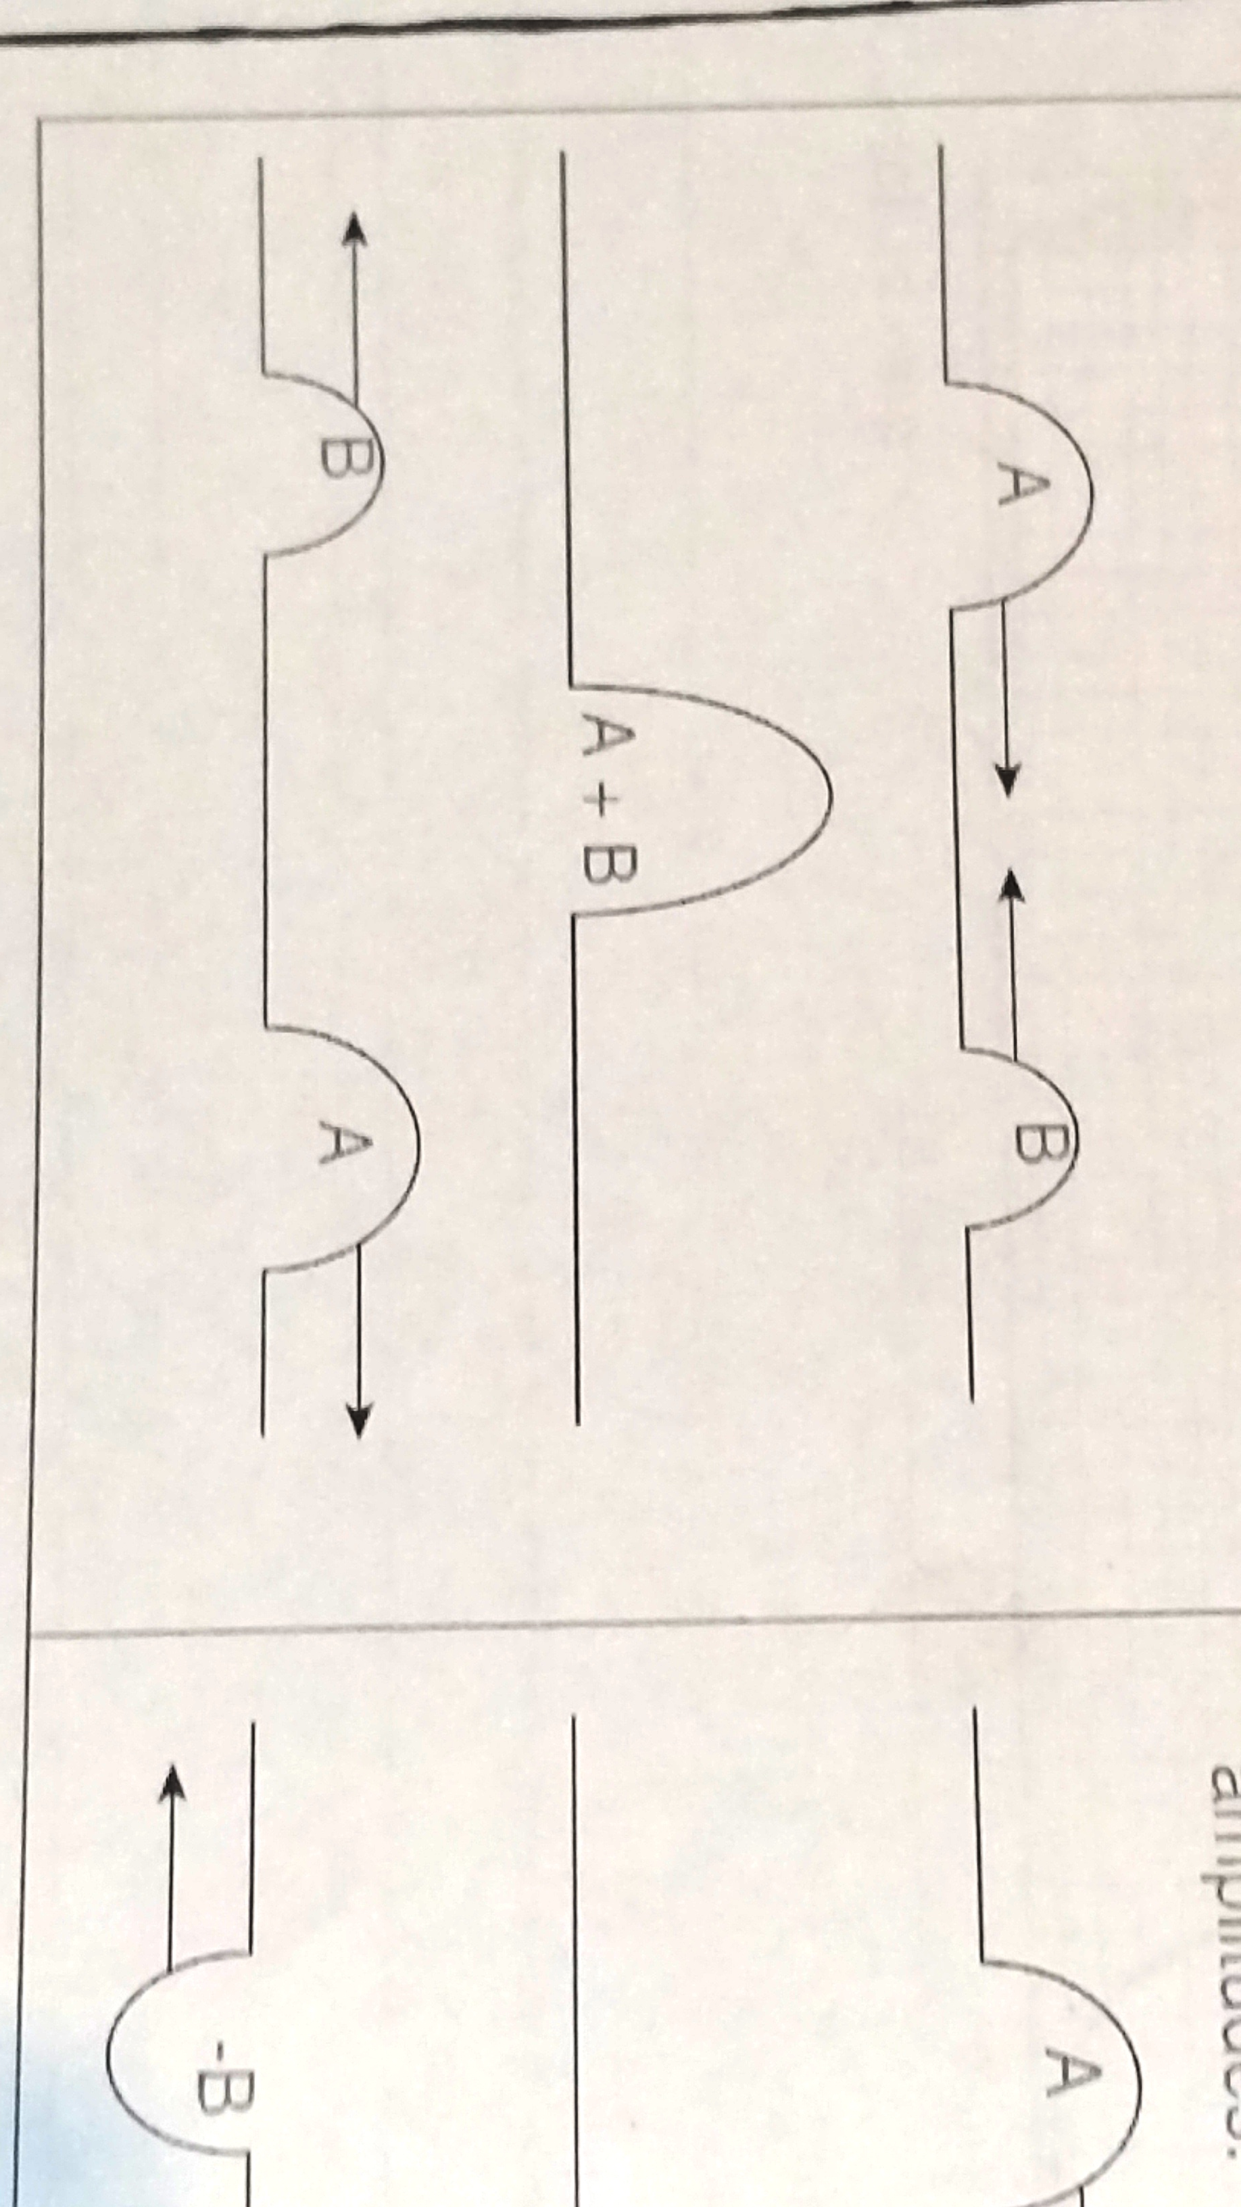
Criteria for sketch | Mark
Shape of the resulting wave.  Vorm van die golf | ✓✓
Resulting Amplitude indicated as A+B.  Resultante amp aangedui as  A + B | ✓

(3)
5.3.2
Criteria for sketch | Mark
Shape of the resulting wave.  Vorm van die res golf | ✓✓
Resulting Amplitude indicated as A+ (-B).  Resultante amp aangedui as  A + B | ✓
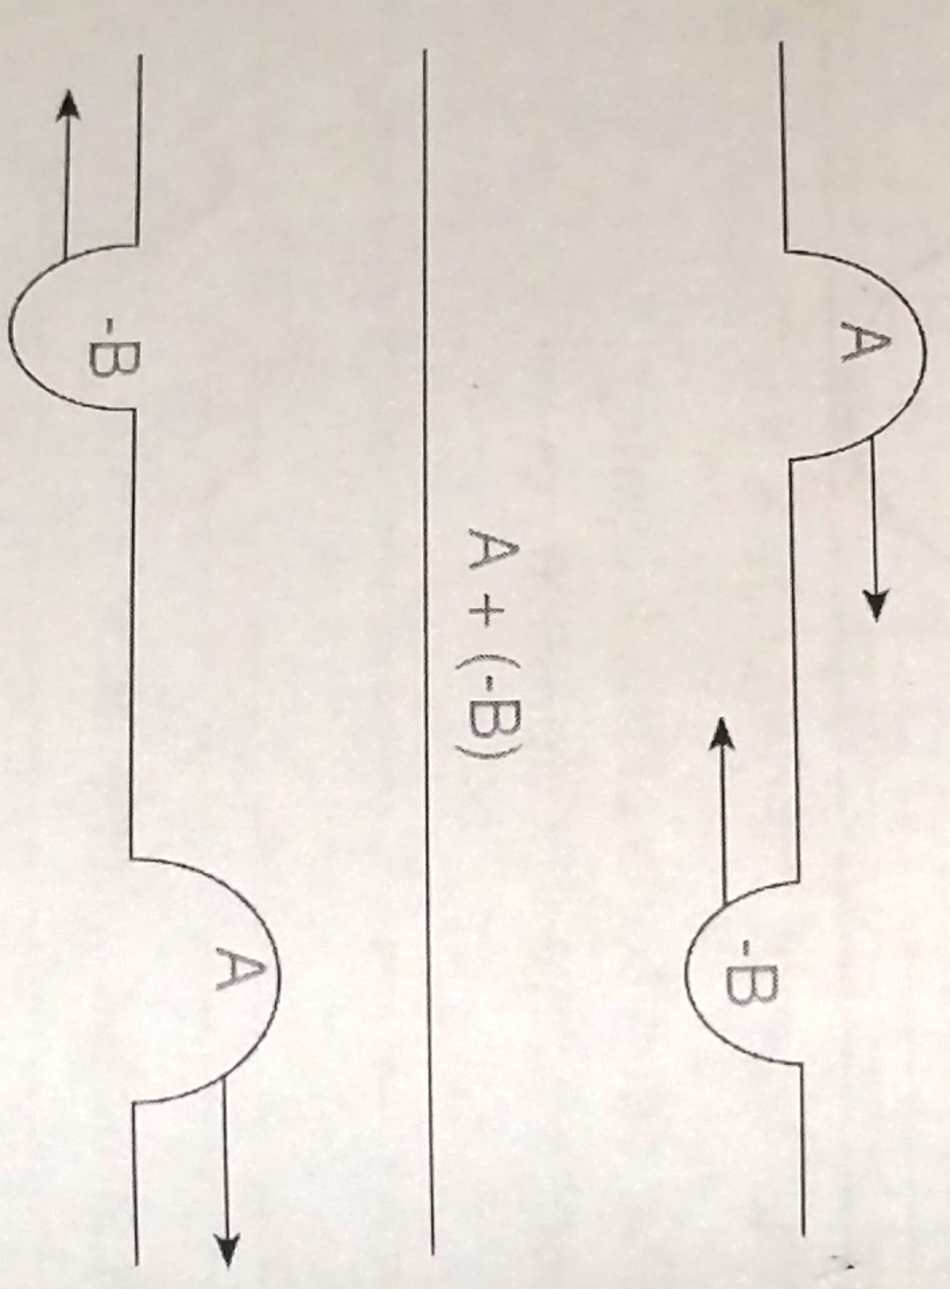

(3)

5.4.1 Wave B ✓ Golf B ✓ (1)
5.4.2 Wave B has a high frequency / short wavelength✓ resulting in high
Note / pitch✓
Golf B het ‘n hoë frekwensie/kort golflengte wat verantwoordelik is vir n hoë noot (2)

5.5.1 Amplitude. ✓ (1)

5.5.2
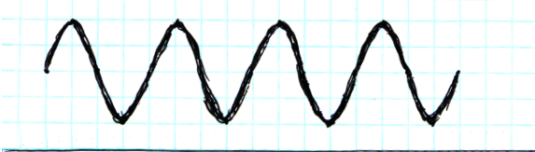
Criteria for sketch | Mark
Same number of waves (i.e 4 waves)  Dieselfde hoeveelheid golwe | ✓
Same wavelength (4 units)  Dieslefde golflengte | ✓
Amplitude is doubled (2 units)  Die amplitude verdubbel | ✓

(3)

5.6 Sonar (Pregnancy) ✓ / Treatment (of Kidney stones) / ✓Diagnosis (Blood flow
in arteries) ✓ (Any 2)
Sonar/ Nierstene/Bloedvloei (enige 2) ✓ ✓ (2)

[19]
QUESTION/VRAAG 6

6.1.1 Over exposure can damage eyes and skin OR Can cause skin cancer.
(Any ONE) ✓
Blootstelling kan die oë of vel beskadig of velkanker veroorsaak (enige 1) ✓ (1)
6.1.2 Over exposure can lead to cancer or skin damage. ✓
Oormatige blootstelling kan tot kanker of velskade lei. ✓ (1) 6.2 Photon: A packet of energy found in light. ✓✓
' n Foton: ‘n Pakkie energie ✓✓ (2)

6.3 Light A: Lig A
E = h f✓
E = 6.63×10⁻³⁴ J.s × 5, 56×10¹⁴Hz✓
E = 3, 69 × 10⁻¹⁹ J✓ (3)
Light B: Lig B
$E=\frac{\text{hc}}{λ}$✓
E =$\frac{(6,\text{63}×{\text{10}}^{−\text{34}})(3×{\text{10}}^{8})}{\text{390}×{\text{10}}^{−9}}$✓
E = 5, 1 ×10⁻¹⁹ J✓ (3)
3, 69 × 10⁻¹⁹ J < 5, 1 ×10⁻¹⁹ J ✓ (1)
Therefore, light B has the highest energy✓
Dus het lig B die hoogste energie ✓ (1)

[12]

QUESTION/VRAAG 7

7.1 (NH₄ )₂CO₃ ✓ → CO₂✓ +H₂O✓ + 2✓ NH₃✓ (5)
7.2 Oxygen ✓+ Sulphur dioxide ✓→Sulphur trioxide✓ (3)

Suurstof + swaeldioksied → Swaeltrioksied
[8]
QUESTION 8

8.1 17ºC ✓ (1)
8.2 117⁰C ✓ (1)
8.3 Stays constant✓Bly konstand (1)

8.4 Its boiling point is greater than 100⁰C✓✓ Die kookpunt is hoër as 100⁰C (2)

8.5 Gaseous phase ✓✓ Gasfase (2)

QUESTION/VRAAG 9

9.1.1 Magnetic Field: A region in space where a magnet or ferromagnetic
material will experience a force (non-contact). ✓✓
Magnetiese veld: ‘n Omgewing in die ruimte waar ‘n magneet of ferromagnteiese material ‘n krag sal ervaar ✓✓ (2)

9.1.2 -Some field lines are crossing. ✓
-Direction of some field lines moves from the South pole. ✓
-Space between field lines at some point of greater field bigger than where
at point where field is weak. ✓
-Party veldlyne kruis ✓
-Die rigting van party veldlyne is vanaf die suidpool✓
-Die spasie tussenj veldlyne by party punte is groter en lyk dus swakker as punte waar die eintlik swakker is ✓ (3)

9.1.3 A Compass. ✓’n Kompas (1)

9.1.4
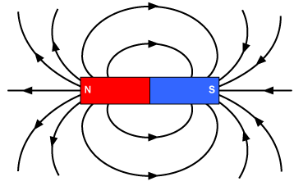
Criteria for sketch | Mark
Direction of lines in at south pole, out at north pole. Uit Suid en in by Noord | ✓
Correct shape for field pattern as shown.  Korrekte vorm vir veldpatrone | ✓
(2)

9.2 Earth’s magnetic field offers protection from solar winds (Stream of
radioactive and charged particles sent into space at high speeds due to
reaction on the reactions on the sun) ✓✓
Die aarde se magnetise veld beskerm ons van sonwinde (Stroom van radioaktiewe en gelaade deeltjies wat vanaf die son teen ‘n hoë spoed na die aarde aankom✓✓
(2)

[10]

QUESTION /VRAAG10
10.1.1 Lost electrons. ✓Elektrone verloor (1)
10.1.2 Object is positively charged✓ showing a deficiency/shortage of
electrons✓.
Voorwerp is positief gelaai ✓ en het dus ‘n tekort aan elektrone✓ (2)

10.1.3 Q = nq_{e}
+3.2 × 10⁻¹⁵ ✓ = n (1, 6 x 10 ^{– 19}) ✓
∴ n = (electrons) ✓ (3)

10.2 $Q_{\text{net}}=\frac{Q_{1}+Q_{2}}{2}$✓

$Q_{\text{net}}=\frac{−1\text{.}6x{\text{10}}^{−9}+1\text{.}2x{\text{10}}^{−9}}{2}$✓

Q_{net} = 4.8 x 10⁻⁹ C ✓ (3)
10.3 Terminal potential difference: The voltage measured across the
terminals of the battery when charges are flowing in circuit. ✓✓
Terminale potensiaalverskil; Die volts gemeet oor die terminale van die battery
wanner lading deur die stroombaan vloei ✓ ✓ (2)

10.4.1 Q = I t ✓
Q = 1, 5 × 10✓
Q = 15 C ✓ (3)

10.4.2 $R_{1}=\frac{V}{I}$✓
$R_{1}=\frac{2}{1\text{.}5}$✓
R₁ = 1. 33 Ω ✓ (3)

10.4.3 | OPTION 1 | OPTION 2
 | V_{T}=V₁ +V₂✓  ∴ V₂= (3-2) ✓  V₂ =1V ✓  but $R_{2}=\frac{V}{I}$✓  $R_{2}=\frac{1}{1\text{.}5}$✓  R₂ = 0, 67 Ω ✓ | $R_{T}=\frac{V_{T}}{I_{T}}$✓  $R_{T}=\frac{3}{1\text{.}5}$✓  R_{T} = 2 Ω ✓  but R_{T}=R₁ +R₂✓  ∴ R₂= (2-1, 33) ✓  R₂ =0, 67V ✓
(6)
[23]

TOTAL : 150

